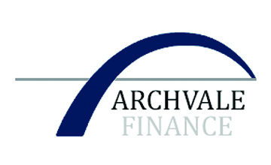
Registered Office:
Suite 402, 118 Christie Street
St. Leonards, NSW 2065
M-+403 353 609
E-Mail: john@archvalefinance.com

FACT SHEET
FOR
PROJECT FUNDING

This funding program is provided exclusively by Archvale Finance.

This is not a loan, but an alternative equity funding facility

Our funding facility can provide funding for: development and construction of multiple residential, commercial, shopping centres, retail, hotels, resorts, warehousing, subdivisions, alternative energy, agriculture and other viable projects.

It is a monthly draw down facility and is not suitable for direct purchases. Funding is available from Euro 50 million to Euro 500 million. (larger projects are on a case-by-case basis). For infrastructure projects, funding is available up to USD/Euro 2 billion.

The equity Archvale will require is 10% - 15% of the on-completion value.

There is no debt repayment, only the repayment of the funds provided plus the redemption of the equity.

There is no interest and is Non-Recourse (No directors or principals guarantees).

Funding includes all hard and soft costs.

The project must stand on its own merits. Funding with a cash deposit can be up to 90% of total costs including settlement fees. The remaining 10% must be a cash deposit to facilitate the funding facility and is payable once all documents and agreements are signed by both parties.

This can be done as a “Secure Funds” program which requires a deposit of 15% in cash.
The deposit is transferred directly to a major national law firms escrow account. The funds are immediately moved to a non-depletion account. (This means the funds cannot be withdrawn, used for any purpose, or transferred. This process gives the developer total security.

The full amount of deposit is returned to the client within 45 days, without any offsets.

This means funding under our “Secure Funds” program Archvale provides 100% of total costs.

We fund in USD, Euro, AUD and GBP and can fund in most qualified countries throughout the world. The term of the facility is up to 5 years unless otherwise negotiated.

